Test Case: tc001_SPX_Dev5_Crear_Requisicion_Spot_Tipo_Cobro_CC
Step 1 - Enter username and password and click to button Enter : Credentials Entered
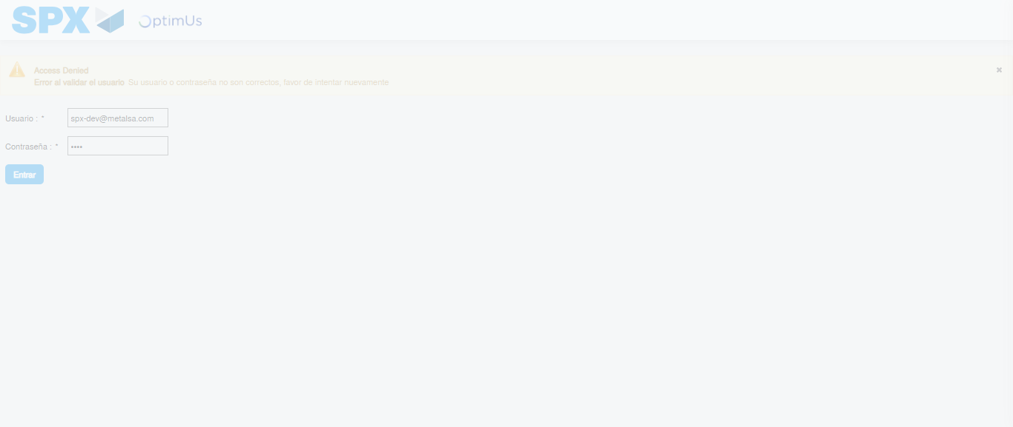Image file-name: QC_Testing-tc001_SPX_Dev5_Crear_Requisicion_Spot_Tipo_Cobro_CC-1783980718393

Step 2 - Select to UEN and Access to Spot Buy Requisitions : UEN Correctly selected and Correct access
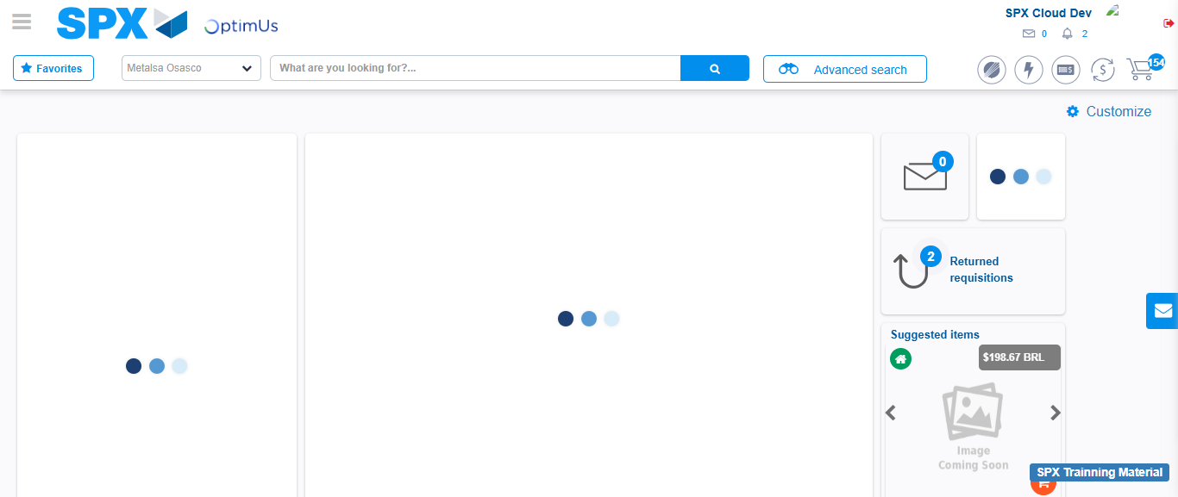Image file-name: QC_Testing-tc001_SPX_Dev5_Crear_Requisicion_Spot_Tipo_Cobro_CC-1783980745332

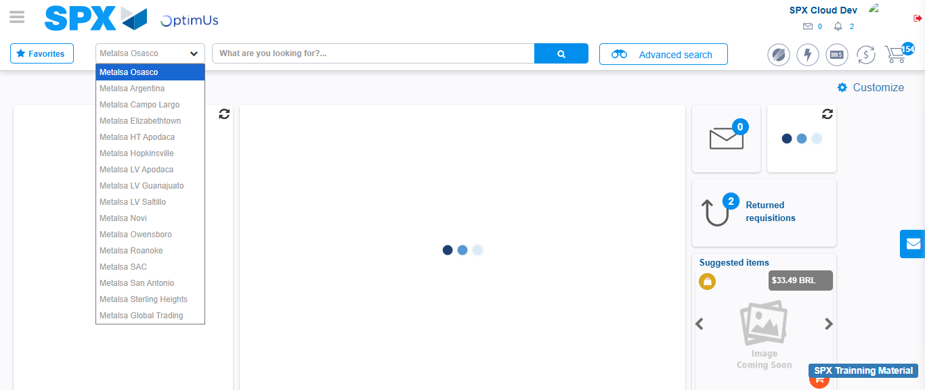Image file-name: QC_Testing-tc001_SPX_Dev5_Crear_Requisicion_Spot_Tipo_Cobro_CC-1783980747896

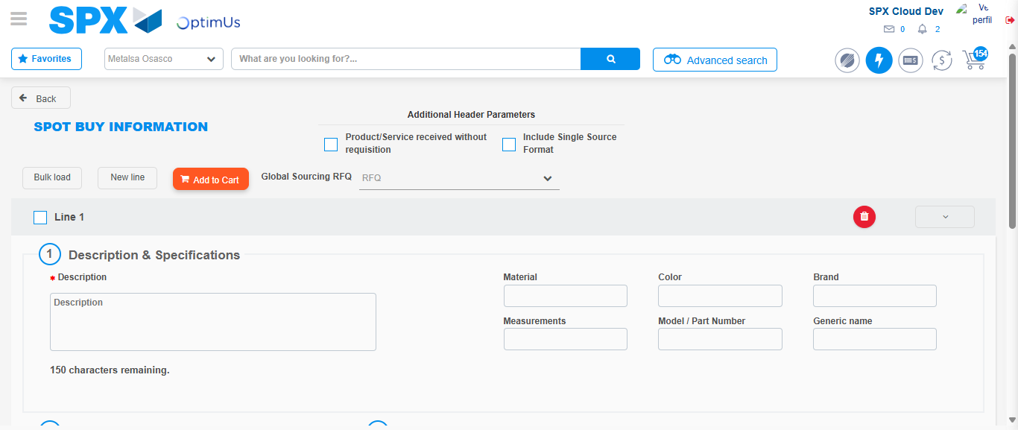Image file-name: QC_Testing-tc001_SPX_Dev5_Crear_Requisicion_Spot_Tipo_Cobro_CC-1783980775356

Step 3 - Data Capture Spot Buy Requisition : Data captured correctly
Image file-name: QC_Testing-tc001_SPX_Dev5_Crear_Requisicion_Spot_Tipo_Cobro_CC-1783980775578

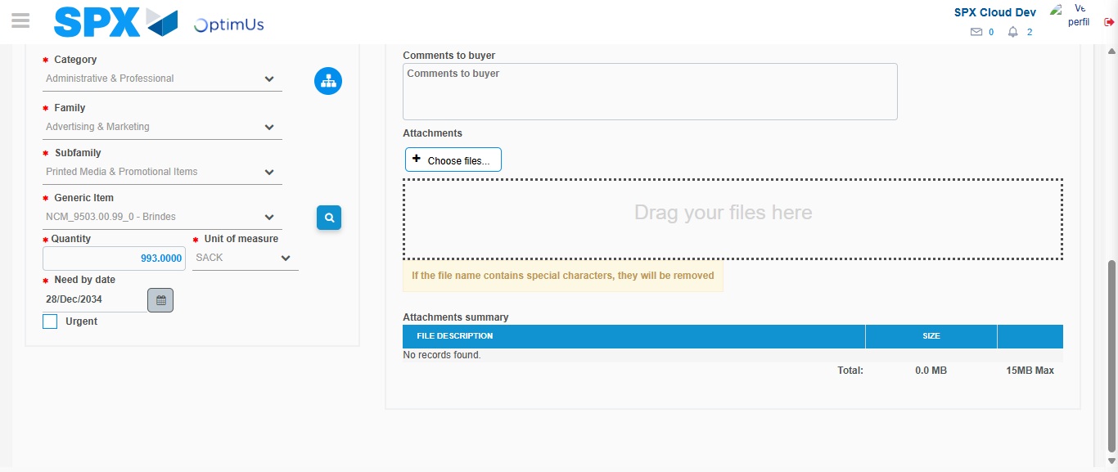Image file-name: QC_Testing-tc001_SPX_Dev5_Crear_Requisicion_Spot_Tipo_Cobro_CC-1783980786762

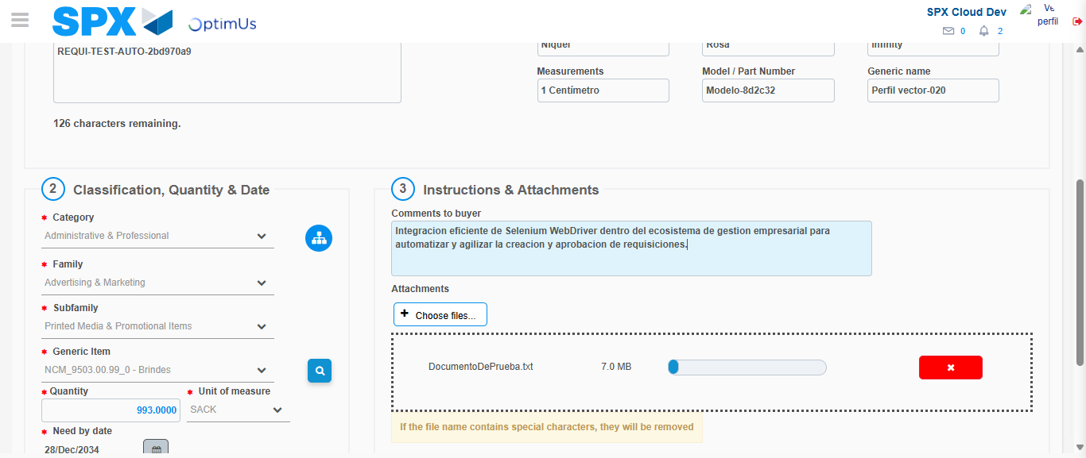Image file-name: QC_Testing-tc001_SPX_Dev5_Crear_Requisicion_Spot_Tipo_Cobro_CC-1783980787500

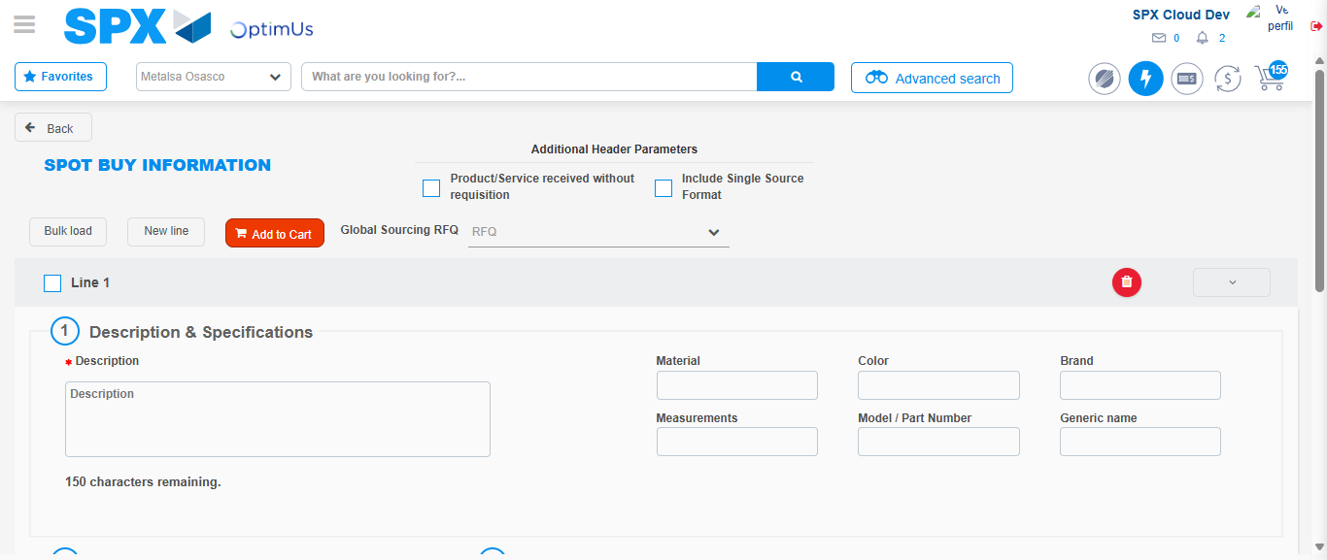Image file-name: QC_Testing-tc001_SPX_Dev5_Crear_Requisicion_Spot_Tipo_Cobro_CC-1783980797359

Step 7 - Return to Main Page SPX : Return to Main Page SPX
Image file-name: QC_Testing-tc001_SPX_Dev5_Crear_Requisicion_Spot_Tipo_Cobro_CC-1783980745332

Image file-name: QC_Testing-tc001_SPX_Dev5_Crear_Requisicion_Spot_Tipo_Cobro_CC-1783980747896

Image file-name: QC_Testing-tc001_SPX_Dev5_Crear_Requisicion_Spot_Tipo_Cobro_CC-1783980775356

Image file-name: QC_Testing-tc001_SPX_Dev5_Crear_Requisicion_Spot_Tipo_Cobro_CC-1783980799575

Image file-name: QC_Testing-tc001_SPX_Dev5_Crear_Requisicion_Spot_Tipo_Cobro_CC-1783980799760

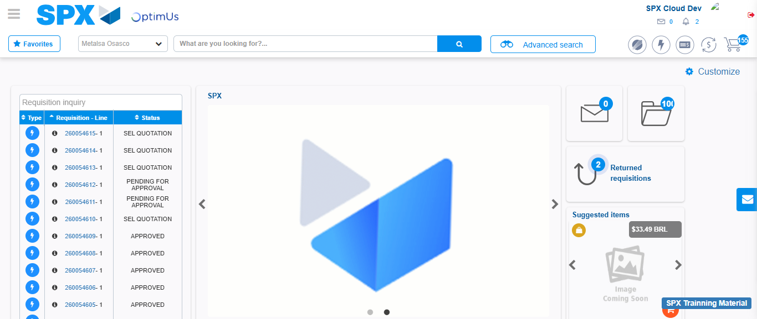Image file-name: QC_Testing-tc001_SPX_Dev5_Crear_Requisicion_Spot_Tipo_Cobro_CC-1783980820755

Step 8 - Log Out : Log Out SPX
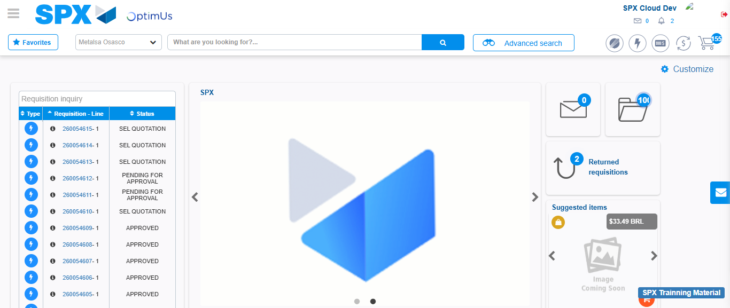Image file-name: QC_Testing-tc001_SPX_Dev5_Crear_Requisicion_Spot_Tipo_Cobro_CC-1783980821025

